A Sparse Hypercube 3-spanners
W. Duckworth, M. Zito
Preliminaries
Definition:
The Hypercube 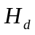: is a graph with n = 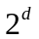 vertices. If we label all the vertices with the binary representations of the numbers 0,…. − 1, then two vertices are connected by an edge if and only if their labels differ in precisely one bit position (if the labels differ in bit position i then that edge is said to belong to the ith dimension). Each label has precisely d bits.
Cartesian Product: The Hypercube can be represented as a Cartesian product of two smaller Hypercubes. If = 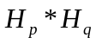, then d = p + q and can be partitioned into 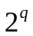 (vertex disjoint) copies of 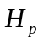 and 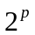 copies of 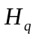 so that each v V() belongs to exactly one copy of and one copy of .
Lemma 1. For every positive integer k, the Hypercube , where d =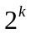-1, has a minimum dominating set of size exactly 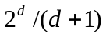.
Lemma 2. For every d 1, the Hypercube has a dominating set of size at most 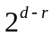, where r is the largest integer such that 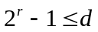.
Constructing sparse Hypercube 3-spanners
The following is a algorithm designed by D. Peleg, J.D. Ullman, An optimal synchroniser for the hypercube, SIAM J. Comput. 18 (4) (1989) 740-747.which give a general upper bound of 7n for all values of d when p and q are chosen as close to each other as possible.
Considers as the Cartesian product of two smaller Hypercubes, and and adds to the spanner every edge of the forms
Type(1): { (x, y), (x, 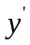)} | ( 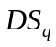 and { y, } E()),
Type(2): { (x, y), (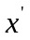, y)} | ( 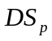 and { x, } E()),
Type(3): { (x, y), (x, )} | (x and { y, } E()),
Type(4): { (x, y), (, y)} | ( and { x, } E()),
The above is a sparse 3-spanner ,proof:
All other edges of are of the forms
Type(5): { (x, y), (x, )} | ( and y, and { y, } E()),
Type(6): { (x, y), (, y)} | ( and x, and { x, } E()),
Let { (x, y), (x, )} be an edge of Type (5) (the argument for edges of Type (6) is analogous). Note that vertex x is not a member of a dominating set in any copy of or else the edge { (x, y), (x, )} would be of Type (3) and have already been added to the spanner. Vertex x V() must be dominated by a vertex V() and now edges { (, y), (, )}, { (x, y), (, y)} , and { (x, ), (,)} all are in the spanner because they are of Type (3), (2) and (2), respectively. We therefore have a path of length 3 for every edge not already in the spanner.
Lemma 3. For every integer k; the Hypercube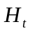 ; where t =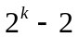, has a 3-spanner of size at most (3 − 4=(t + 2))2 t .
The algorithm presented in this paper:
1.rather than choosing the values of p and q close together, we
- fix p close to the value of for some k and choose q consequently. Then we¤ Build a sparse 3-spanner in each copy of Hp.
¤ 2.For every vertex that is a member of the dominating set for, (based on the construction of the 3-spanner in ), add a full copy of.
The reason it is a sparse 3-spanner: Consider an edge { (x, y), (x, )} , of a copy of , that has not been added so far. Since the 3-spanner for each copy of is built using the construction in [3], every edge connected to every member of the dominating set for is present in the spanner. Vertex x is then dominated by a vertex in , hence both edges { (x, y), (, )}and{ (x, ), (, )}, belong to the 3-spanner. The edge { (, y), (, )} is also in the spanner as it belongs to one of the full copies of . We therefore have a path of length 3 for all edges that are not already in the spanner.
Lemma 4. The Hypercube; where p = 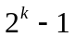 for some integer value of k; has a 3-spanner of size at most 3 * .
Theorem 1. For every integer d 1; the size of a minimum-edge 3-spanner for is at most 4 * .
Theorem 2. A 3-spanner of the Hypercube has at least 3d/2(d + 3) edges.
- Created by: Shine-Hyue Wu
Date: Oct . 2, 2001

- Ps.這一頁是老師平行演算法的講義:
The hypercube is the cross product of smaller cubes, and the cross product of linear arrays.
A graph G = (V, E) is the cross product of graphs, G₁=(V₁,E₁), G₂=(V₂,E₂), …, G_{K}=(V_{K},E_{K})
if and
E = {{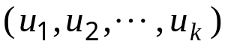, 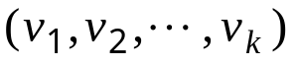} | 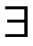 j such that 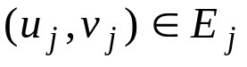 and 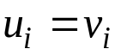 for all 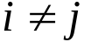}.
Notation : 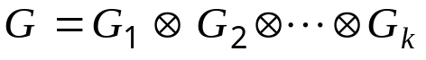
e.g.
